 HttpSession interface->

DIffrence bw cookies and http session-

Cookies and session both store information about the user (to make the HTTP request stateful) but the difference is that cookies store information on the client-side (browser) and sessions store information on the server-side.

A cookie is limited in the sense that it stores information about limited users and only stores limited content for each user. A session is not limit in such a way.

container creates a session id for each user.The container uses this id to identify the particular user.An object of HttpSession can be used to perform two tasks:

1. bind objects
2. view and manipulate information about a session, such as the session identifier, creation time, and last accessed time.

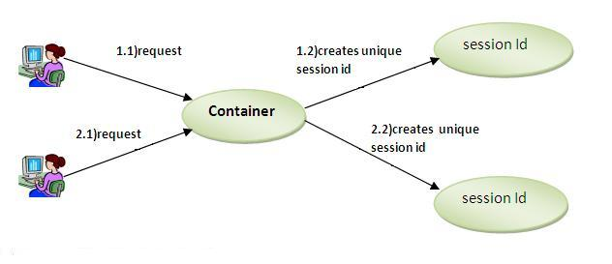

### **How to get the HttpSession object ?**

HttpServletRequest interface provides two methods to get the object of HttpSession:

1. **public HttpSession getSession():**Returns the current session associated with this request, or if the request does not have a session, creates one.
2. **public HttpSession getSession(boolean create):**Returns the current HttpSession associated with this request or, if there is no current session and create is true, returns a new session.

